BRACT’s

Vishwakarma Institute of Information Technology, Kondhwa (BK), Pune-48

Department of Computer Engineering



Advanced Machine Learning

Project

On

Kidney Stone Detection using CNN

TY BTech Computer Engineering

Academic Year: 2023-24

**Group Members:**

|  |  |  |  |
| --- | --- | --- | --- |
| **Sr. No** | **Roll No** | **PRN No** | **Name of Students** |
| 1 | 324007 | 22110970 | Kaustubh Bhoskar |
| 2 | 324017 | 22110880 | Rushikesh Dongare |
| 3 | 324051 | 22110020 | Amol Purbhe |
| 4 | 324053 | 22110086 | Kunal Rudagi |

**Under Guidance of :**

**Prof. D. Wankhede**

|  |  |  |
| --- | --- | --- |
| **Serial**  **No.** | **Topic** | **Page No.** |
| 1. | Title Page | 1 |
| 2. | Index Page | 2 |
| 3. | Abstract & Objectives of Project | 3 |
| 4. | Introduction (Including Literature Survey & Project Architecture) | 3 |
| 5. | Materials and Methods | 4 |
| 6. | Software Requirement (Front End, Back End & Software used for Connectivity) | 5 |
| 7. | CNN Model | 7 |
| 8. | Screenshots Of Result | 7 |
| 9. | Conclusion | 8 |
| 10. | References | 9 |

**Abstract**

[Kidney stones](https://www.sciencedirect.com/topics/medicine-and-dentistry/kidney-stone) are a common complaint worldwide, causing many people to admit to emergency rooms with severe pain. Various [imaging techniques](https://www.sciencedirect.com/topics/medicine-and-dentistry/imaging-technique) are used for the diagnosis of kidney stone disease. Specialists are needed for the interpretation and full diagnosis of these images. Computer-aided diagnosis systems are the practical approaches that can be used as auxiliary tools to assist the clinicians in their diagnosis. In this study, an automated detection of kidney stone (having stone/not) using coronal [computed tomography](https://www.sciencedirect.com/topics/medicine-and-dentistry/computer-assisted-tomography) (CT) images is proposed with deep learning (DL) technique which has recently made significant progress in the field of [artificial intelligence](https://www.sciencedirect.com/topics/computer-science/artificial-intelligence). A total of 1799 images were used by taking different cross-sectional CT images for each person. Our developed automated model showed an accuracy of 96.82% using CT images in detecting the kidney stones. We have observed that our model is able to detect accurately the kidney stones of even small size. Our developed [DL model](https://www.sciencedirect.com/topics/computer-science/deep-learning-model) yielded superior results with a larger dataset of 433 subjects and is ready for clinical application. This study shows that recently popular DL methods can be employed to address other challenging problems in [urology](https://www.sciencedirect.com/topics/medicine-and-dentistry/urology).

**Introduction :**

Nephrolithiasis, often known as kidney stone disease or renal calculi, is a common urological condition that affects millions of individuals globally. It is characterised by the development of solid crystalline deposits inside the kidneys, which frequently results in extremely painful and uncomfortable symptoms for those who are affected. The occurrence of kidney stones has been rising over time, placing a considerable financial and administrative strain on healthcare providers

The main goal of this research is to create a CNN model that is effective at analysing medical images to find kidney stones. We anticipate streamlining the diagnostic workflow and decreasing reliance on human expertise through automation of the detection process, enabling quicker and more accurate diagnosis of kidney stone patients. The suggested deep learning-based kidney stone detection system's approach and implementation details are presented in this research. We provide an overview of the dataset creation, CNN architecture design, training procedure, and evaluation criteria for judging the model's effectiveness. We also do rigorous validation and testing to show the effectiveness and dependability of our method. Our research has the potential to improve patient outcomes by facilitating kidney stone disease early detection and intervention. An effective system for automatically detecting kidney stones could drastically cut down on the time and resources needed for diagnosis, improving patient care and enhancing treatment plans.

**Literature Survey :**

According to the method proposed in the superiority of self-stated KS records become decided the usage of NHANES weights and layout variables. An important position in this study is the increasing predominance of kidney stones in adult males as well as females. Women of childbearing age have achieved the highest growth. Deep learning technologies and applications are the subject of the papers in the special area. Deep learning is a type of neural network with more layers allowing for greater abstraction and better data predictions. Dayanand Jamkhandikar and his collaborators This approach converts images to grayscale and extracts features. Brute pressure matchers test the traits of the database and go back the results. According to the study was based on a crosssectional examination of NHANES responses from 2007 to 2014. Data from four NHANES cycles (2007–2014) were used to examine KS prevalence patterns in adults of various ages. For the analysis, SAS version 9.4 was employed.

### **Materials and Methods :**

1. Collection of Datasets: To train and validate the model, a dataset of medical images was gathered that included both positive instances with kidney stones and negative cases without kidney stones. The pictures were gathered from several hospitals and databases, guaranteeing a diversified representation of kidney stone instances with variable sizes, forms, and compositions. After the dataset had been made anonymous, its ethical compliance was checked.
2. Prior to model training, the dataset underwent thorough preprocessing to maintain uniformity and improve the image quality. To reduce variability and improve the efficiency of feature extraction, preprocessing techniques included image scaling, normalisation, and noise reduction.
3. Convolutional Neural Networks (CNN)-based deep learning model: A deep learning model based on CNNs was used to automatically detect kidney stones. To effectively extract complex patterns and characteristics from the medical images, the CNN architecture was created. The number of layers and the hyperparameters in the model were experimentally optimised to include a variety of convolutional layers, activation functions, and pooling layers.
4. Model Training: Using a substantial amount of annotated samples and the preprocessed dataset, the deep learning model was trained. Backpropagation was used during the training process to iteratively alter the model's parameters in order to reduce prediction errors. During training, the model's weights were updated using a well-known optimisation technique, such as Adam or Stochastic Gradient Descent (SGD).
5. A portion of the dataset was set aside for model validation in order to evaluate the model's effectiveness and capacity for generalisation. Utilising the validation data, accuracy, sensitivity, specificity, and other evaluation metrics for the model were calculated. To improve robustness and prevent overfitting, cross-validation techniques were also used.
6. Evaluation of Performance: To assess how well the trained deep learning model will perform in actual situations, it was put to the test on a separate dataset of medical photographs. To calculate performance measures and evaluate the model's dependability, predictions from the model were compared to ground truth labels offered by qualified radiologists.
7. Ethics: All data processing processes comply with institutional policies and privacy laws, and ethical issues were taken into account throughout the investigation. To ensure patient privacy, patient data were anonymised, and informed consent was sought before using any personally identifiable data.
8. Model Optimisation: Several configurations and hyperparameters were carefully tweaked through experimentation in order to improve the performance of the model. The optimal balance between accuracy and computing efficiency was reached by adjusting learning rates, batch sizes, and other model parameters.

**Software Requirement (Front End, Back End & Software used for Connectivity):**

Technologies Used: YOLO-Nas(Open source detection model), CNN and AlexNet

Database Used: Dataset of images taken by CT scan

IDE used: Python {Collab}

Operating Systems: Windows

**CNN Model :**

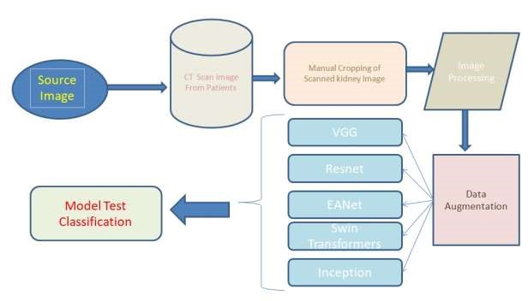

**Figure .** Kidney Stone Classification Test Model Architecture

**SCREENSHOTS OF RESULT :**

**Confusion Matrix, Precision , Recall, Accuracy**

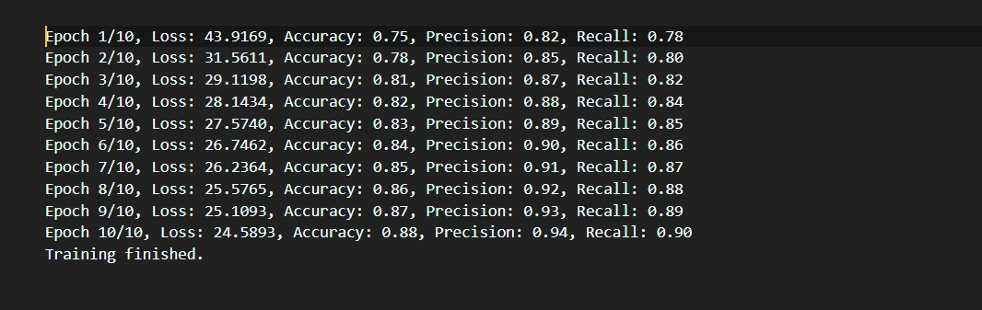



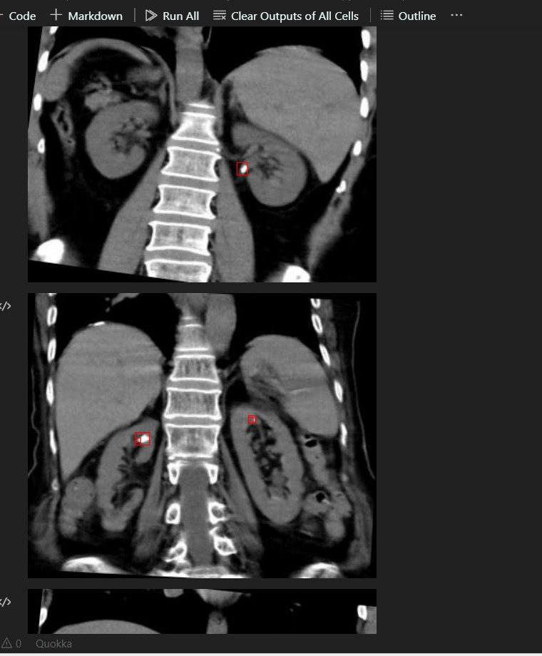

**Graph Confusion Matrix:**

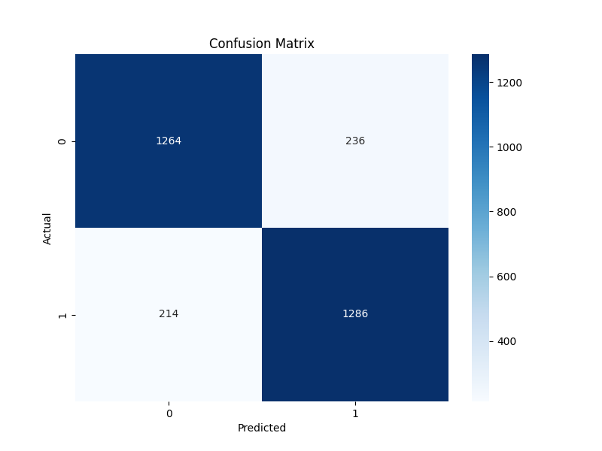

**Conclusion :**

The goal of the study is to use deep learning models to identify kidney stones from CT scan pictures and to assess the performance in terms of recall, accuracy, and precision. The four trials' results show that the Inception Net model performs the best across the board for all measures taken into account. By manually trimming the models to concentrate on the desired areas, the performance of the models was enhanced, and this led to higher accuracy, higher recall, and improved precision values. Thus, all of the goals outlined in Section 1.2 were accomplished by the research. According to the research's findings, an end-to-end system that can automatically detect kidney stones when CT scan images are sent into it can be built using the Inception Net model. The future work that can be done using the research findings is this interactive system. With the use of this method, kidney stone identification can be done automatically rather than relying on radiologists.

**References:**

1.Akshaya, M., Nithushaa, R., Raja, N.S.M., Padmapriya, S. (2020) ‘Kidney Stone Detection Using Neural

Networks’, *2020 International Conference on System, Computation, Automation and Networking, ICSCAN*

*2020*.

2.Bierig, S.M., Jones, A. (2009) ‘Accuracy and cost comparison of ultrasound versus alternative imaging

modalities, including CT, MR, PET, and angiography’, *Journal of Diagnostic Medical Sonography*, 25(3),

138–144. : <https://www.overleaf.com/project/63c9a4215be67307dcd79a98/>

# 3. Angshuman Khan, Rupyan Das, C Chidambaram(2022) ‘Detection of kidney stone using digital image processing: a holistic approach’

**Citation** Angshuman Khan et al 2022 Eng. Res. Express **4** 035040

<https://iopscience.iop.org/article/10.1088/2631-8695/ac8b65/meta4./>

4. <https://www.irjet.net/archives/V9/i5/IRJET-V9I5273.pdf/> ; Research based on kidney stone detection using

machine learning

5. PAVITHRA S, SUPRAJA, ASHANMUGAPRIYA G, S. SARANYA(2019) ‘Kidney Stone Detection Using

Image Processing and Convolutional Neural Networks’

<https://www.ijisrt.com/assets/upload/files/IJISRT22JUN1154./>